|  |  |  |  |  |  |  |  |  |  |  |
| --- | --- | --- | --- | --- | --- | --- | --- | --- | --- | --- |
| **UNIVERSITY FPT APTECH**    **FACULTY OF INFORMATION TECHNOLOGY**    **LEARNING THEME REPORT**  **ADVANCED WEB PROGRAMMING PROJECTS**  **TOPIC:**  **BUILDING EDUCATION MANAGEMENT WEBSITE**  **Zeal Education**   |  |  | | --- | --- | | **Students perform** | **: BÙI ANH TUẤN**  **MAI HUY HOẠT**  **NGUYỄN ĐỨC HUY**  **NGÔ LÊ MINH TÙNG**  **ĐINH VĂN LINH** | | **Instructors** | **: MAN NGỌC LAM** | | **Specialized** | **:INFORMATION TECHNOLOGY** | | **Class** | **: T2111E** | | **lock up** | **: 2021-2023** | |

TABLE OF CONTENT  
THANK YOU 1

PREAMBLE 2

CHAPTER I: GENERAL INTRODUCTION 3

1. General introduction 4
   1. Purpose and goals 4
   2. Project scope. 4
2. Describe the overall functions of the system. 5
   1. System functions.. 5
   2. Administrator functions. 5
   3. Client function. 5
3. Communication required. 6
   1. User interface. 6
   2. Hardware interface. 6
   3. Software interface. 6

1. Non-functional requirements 7
   1. Safety requirement 7
   2. Security requirements. 7
   3. Software quality requirements. 7
   4. Installation environment requirements. 7

**CHAPTER II: ACTUAL SURVEY ON CUSTOMERS' REQUIREMENTS AND NEEDS**

**1**. System status survey

1. Survey site 9
2. Survey purpose. 10
3. Respondents. 11
4. Investigative sources. 12

CHAPTER III: SYSTEM ANALYSIS ............15  
 1. Identify Actors 16

2. Function hierarchy 17

3. General Use-Case Diagram 18

**4.** Specification of Use-case diagram details 19

a. Use-case 'Login' of Admin

b. Use-case “Product Type Management”

c. Use-case “Product Management”

d. Use-case "Purchase product"

e. Use-case "View products"

5. Sequence diagram

a. Admin login function chart

b. Function chart "Add,Edit,Delete" products of Actoc "Admin"

c. Function chart "Add,Edit,Delete" of Actor "Admin"

d. Functional chart "Buy, Pay" products by Actor“Admin”

CHAPTER IV: DESIGN AND READ THE DATABASE

1. Indentify Database Tables
2. Table “Account”
3. Table “bath”
4. Table “course”
5. Table “event”
6. Table “exam”
7. Table “faculty”
8. Table “feedBack”
9. Table “reportScholar”
10. Table “role”
11. Table “scholar”
12. Table “scholarCourse”
13. Table “scholarExam”
14. Entity Relationship Diagram

CHAPTER V: INTERFACE DESIGN AND READING

1. Homepage
2. Coure page interfacee
3. Coure details page interface
4. Event page interface
5. Login page interface
6. About us page interface
7. Contact us page interface
8. Scholar page interface
9. Admin page interface
10. Catalog management interface
11. Student page interface
12. Exam management interface

CHAPTER VI: SUMMARY

# PREAMBLE

Today, the application of information technology and the computerization is considered as one of the decisive factors in the activities of governments, organizations, as well as companies, it plays a very important role. important, can make powerful breakthroughs.

Along with the continuous development of computer technology and electronic networks, information technology also has high-class technologies and in turn conquers one peak after another. The internet is one of the products of great value and is increasingly becoming an indispensable tool, the main foundation for the transmission and exchange of information globally.

Now, everything related to information becomes easy for users, as long as there is an Internet-connected computer or smartphone, we can enjoy watching movies, listening to music or even shopping. .

In the past time, the issue that needs the most attention from the user side is that there is an online shopping system, no need to go to the place, waste time, but we still have a fashionable outfit, delicious food ... brought to us. to the house. It is for the above reasons that many suppliers are trying to create a system to serve the needs of consumers.

Along with the above factors, our group has applied the knowledge we have learned to this practical topic. That is building a website selling furniture to serve the needs of every consumer. Therefore, we decided to choose the topic "Building an educational management website Zeal Education" as the topic to end our semester.

# CHAPTER I: GENERAL INTRODUCTION

# General introduction

# Purpose and goals

# Welcome to the Zeal Education management website!

# Our website is a powerful and useful platform to support the management and administration process in the field of education. With a combination of technology and education expertise, we are committed to providing a flexible and comprehensive system to help educational institutions improve the quality and effectiveness of their teaching and learning activities. study.

# Our website offers a wide range of education management functions and features to meet the diverse requirements of schools, training centers and other educational institutions. From student and faculty information management, curriculum management, score management, to financial and resource management, we guarantee that our system will save you time, improve effectively and create the best educational environment for your learning community.

# By using our website, you can easily manage student and faculty information, plan instruction, track learning progress, generate reports and statistics, and maintain communication. communicate and interact with parents and the educational community.

# We are committed to providing a great user experience, with a friendly interface that is easy to use and customize to your needs. Explore our website and join us in building a powerful and cutting-edge educational environment.

Contact us today to learn more about how our education administration website can assist you and your organization in achieving success and sustainability in the education sector. sex.

1. **Project scope**

Educational management projects can have a variety of scopes, depending on the specific goals and scope of the project. Here are some common areas in an educational management project:

1. Learning Management: The project focuses on improving learning processes in schools. This may include developing and promoting effective teaching methods, developing appropriate curriculum, and assessing and monitoring student learning progress.

2. Administrative management: The project focuses on improving administrative efficiency in the education system. This includes optimizing the admissions process, managing human resources, managing finances and assets, and ensuring compliance with regulations and policies related to education.

3. Management of teacher training and development: The project focuses on improving the capacity and professionalism of teachers through training activities, professional development, and teaching support. This helps to improve the quality of teaching and learning in schools.

4. Education Quality Management: The project focuses on ensuring education quality through the establishment of standards, regulations and evaluation criteria. Project tasks may include the design and implementation of an educational quality assessment system, monitoring and evaluating the effectiveness of educational programs, and promoting continuous improvement in the delivery of education. education services.

5. Information technology management in education: The project focuses on the use of information and communication technology in the field of education. This includes implementing e-learning management systems, developing mobile apps.

6. Facilities management: The project focuses on the management and development of educational facilities, including the construction, upgrading and maintenance of schools, classrooms, laboratories, and libraries. , fitness area and

other facilities. The goal is to ensure a safe, convenient and responsive learning environment for teaching and learning.

7. Financial and resource management: The project focuses on financial, resource and human resource management in the field of education. Duties may include developing and implementing education budgets, contract and tender management, funding and project management, and allocating human resources to meet teaching and learning needs.

8. Educational Project Management: The project focuses on specific educational project management, from planning, implementing, monitoring and evaluating activities. The objective is to ensure the success and effectiveness of the educational project, meeting the stated goals and requirements.

1. **Describe the overall functions of the system**
2. **System functions**

1. Student information management: The system helps to manage student's personal information, learning, results, learning history. This helps manage enrollment, track learning progress, and assess and report student results.

2. Information management of lecturers: The system allows to manage personal information, experience and expertise of lecturers. It also supports scheduling, teaching assignment management, and teacher performance tracking.

3. Curriculum management: The system helps to manage and track the curriculum, lesson plans, teaching materials, and teaching resources. It provides tools to design, align, and evaluate curriculum according to educational standards and requirements.

4. Score management: The system helps to manage and calculate students' scores, store and update learning results. It provides automatic scoring and generating score reports for students, parents and teachers.

5. Financial management: The system supports financial and resource management in the field of education. It helps to track budgets, expenses, revenue and expenditure, manage contracts and invoices, and generate financial reports.

6. Management of diplomas and certificates: The system stores and manages information about diplomas, certificates, degrees and documents related to education. It helps manage the process of issuing, tracking and verifying diplomas and certificates of students and faculty.

7. Employee record management: Employee information management support system

8. Employee records management: An education management system helps to store and manage personal information, work records, skills, experience, training and other information related to employees. in the education sector. It provides tools to manage employee recruitment, assignment, performance evaluation, and career development.

9. Manage schedules and timetables: The system helps to manage and build school schedules and timetables, including class schedules, teaching schedules, exam schedules and other events. It assists in allocating time, classrooms, teachers and students in an efficient and organized manner

10.Parent information management: The education management system allows to store and manage information related to parents, including personal information, notices, academic results reports, related information communicate and interact with parents. It helps to bridge and maintain communication between the school and parents.

11.Data management and reporting: The system provides the ability to manage and process education-related data, including information collection, storage, processing and retrieval. It provides tools to create and customize reports, statistics, and data analysis to aid decision making and evaluate the effectiveness of the teaching and learning process.

12. Interaction and communication management: The system helps to manage interaction and communication in the educational community, including communication between teachers, students, parents and administrators. It provides communication facilities and channels, including email, instant messaging, online forums and announcements to enhance alignment and effective communication.

**b.** **Administrator functions.**

1. User management: Administrators are responsible for managing user information on the system, including creating new accounts, deleting accounts, setting access rights and updating users' personal information.

2. Student and faculty management: Administrators monitor and manage student and faculty information. They can create, update, and delete student and faculty profiles, manage class rosters, assign instruction, and track student progress.

3. Program management: The administrator is responsible for managing and updating the curriculum on the system. They can create and edit courses, subjects, instructional content, and reference materials.

4. Manage schedules and timetables: Administrators build and manage school schedules and timetables. They schedule classes, events, exams, and other activities.

5. Score management: Administrators manage and track student learning outcomes. They enter grades, create transcripts, and provide information about results to students, parents, and faculty.

6. Financial management: Administrators oversee and manage the school's finances. They track budgets, manage invoices, create financial reports, and perform finance and accounting related tasks.

7. Data management and security: Administrators ensure the safety and security of information on the system. They manage and back up data, ensure compliance with information security regulations, and handle privacy-related issues.

8. User support: Zeal Education administrators provide support and guidance to users using the system. They answer questions, handle technical issues, and make sure the system runs smoothly and efficiently.

Zeal Education administrators play an important role in ensuring the smooth and successful operation of the education management system. They are responsible for information management, user support and ensuring the safety and security of data.

1. **Client function**
2. Personal information management: Students can manage their personal information on the system, including updating contact information, academic records, course registration information and class schedules.
3. Register for courses: Students can register for courses in their program through the system. They can view the list of subjects, choose the right courses, check the class schedule and timetable.
4. Management of learning results: Students can track and manage their learning results on the system. They can view their grades, transcripts, report on learning outcomes and track their learning progress.
5. Access to study materials: Students can access and download study materials, textbooks, lectures and reference materials from the system. This helps them improve their knowledge and prepare for lectures and tests.
6. Submit assignments and take tests online: Students can submit assignments and take tests online through the system. They can submit assignments, take tests and get feedback from instructors through the system.
7. Look up tuition and financial information: Students can look up information about tuition, bills, payments and other financial aid through the system. This helps students understand their financial situation and manage their spending plans..
8. Interact with faculty and other students: Students can interact, discuss and communicate with faculty and other students through interactive tools in the system. They can join forums, discussion groups, send messages and share learning-related information.- Students use the Zeal Education system to manage personal information, track learning progress, access study materials, and interact with faculty and other students. The system helps students enhance their learning experience and effectively manage learning
9. **Communication required**
   1. **User interface**

* Clearly easy to use functions close to users, beautiful and eye-catching interface to attract customers, the program runs properly and stably to meet the requirements of customers.
  1. **Hardware interface**
* There are a traditional protocol between hardware and software, computer speed, configuration enough to run the program
  1. **Software interface**
* Opera system Windows XP and above
* Popular web browsers like Chrome, Firefox, …

1. **Non-functional requirements** 
   1. **Safety requirements**

* Some functions must be logged in to be used
* Account authorization.
  1. **Security requirements**
* Functions can only be performed by explicitly authorized accounts
  1. **Software quality requirements**
* Works well
* Stable
* Scientific presentation
* Well adapted to the installation environment
  1. **Installation environment requirements**
* Suitable for most machines with medium configuration in the field, with Windows XP or higher operating system

**CHAPTER II: ACTUAL SURVEY ON CUSTOMERS' REQUIREMENTS AND NEEDS**

1. **System status survey**
2. **Survey site**

Zeal Education is an online education platform, so there is no specific location to survey the site. The Zeal Education website can be accessed from any location with an internet connection. You just need to access the main Zeal Education website using the web browser on your device, such as a personal computer, laptop, smartphone or tablet. This allows you to experience learning and enjoy the courses and materials Zeal Education offers anytime, anywhere. Zeal Education is an online education platform, so there is no specific location to survey the site. The Zeal Education website can be accessed from any location with an internet connection. You just need to access the main Zeal Education website using the web browser on your device, such as a personal computer, laptop, smartphone or tablet. This allows you to experience learning and enjoy the courses and materials Zeal Education offers anytime, anywhere

1. **Survey purpose**

To identify the Actor, the functions of the system are required, leading to no missing important functions

1. **Respondents**

The Zeal Education website survey audience may include:

1. Students: Zeal Education aims to provide the best learning experience for students. Therefore, students are one of the main subjects surveyed to understand their opinions, needs and feedback regarding the website, user interface, content quality, learning tools and overall experience. available on Zeal Education.

2. Lecturer: For Zeal Education, the opinion and feedback of the lecturer is also very important. Surveys can focus on faculty requirements for teaching platforms, classroom management tools, content quality, and support from Zeal Education to improve teaching and student engagement.

3. Parents: Zeal Education may also conduct surveys of parents to understand their views, desires and suggestions regarding the website, learning process, progress and support for their child. cousin on Zeal Education

(*) The survey audience can be extended to other stakeholders such as education administrators, employers or related partners to evaluate and improve Zeal Education's effectiveness in providing education and support. online learning.

**d. Investigative sources**

1.Zeal Education Official Website: The main website is the most reliable source of information about Zeal Education. This website provides information about courses, curriculum, instructional content, technology used, and system features.

2.Guidelines and References: Zeal Education may provide tutorials, references or articles related to the system and learning experience. These are the official resources from Zeal Education to better understand the functions and features of the website.

3.Reviews from users: Reviews and reviews from current users or alumni of Zeal Education can be searched. Forums, customer review sites, or social media may provide information from users about their experience with the site and the quality of service.

4. Interview with a representative of Zeal Education: You can contact Zeal Education directly to ask for an interview or chat with their representative. This gives you the opportunity to directly discuss, ask questions and gather detailed information about the website and related aspects.

# CHAPTER III: SYSTEM ANALYSIS

1. **Identify Actor**

Students: The primary users of the Zeal Education website, sign up for and participate in courses and programs, access materials, participate in discussions, and interact with faculty and other students. Instructors: Instructors play an important role in Zeal Education by providing instructional content, classroom management, student assessment, and student interaction through the website. Admin: Play the role of managing and maintaining the Zeal Education website, managing users, providing technical support, and managing content. Parents: Persons who have the power to decide or influence their child's choice and participation in courses and programs on Zeal Education. They can interact with the website to track their child's learning progress and provide feedback. Educational administrators: Educational institution administrators, leaders, or representatives use Zeal Education to administer study programs, monitor learning progress, and collect feedback data from students. and lecturers. Employers: Companies, businesses or organizations that may be Actors are interested in Zeal Education to find and recruit candidates with the right skills and knowledge from the courses and programs on the website. . These Actors have different roles and relationships with the Zeal Education website, and each actor contributes to the activity and learning experience on the platform.

1. **Function** **hierarchy**

System administrator:

1. User management: Create and manage user accounts, authenticate users, provide access rights, and manage users' personal information.

2. Course and Curriculum Management: Create, edit and delete courses and programs, assign instructors to courses, manage class schedules and progress.

3. Content management: Upload, manage and categorize learning content, lectures, documents and assignments.

4. Technical Support: Resolve technical issues, user support, and system security.

Lecturers:

1.Create and manage classes: Create classes, manage student lists, send notifications and class information.

2.Content distribution: Upload teaching content, create lectures, study materials, and reference materials for students.

3. Assignment and Assessment Management: Create and assign assignments, evaluate and provide feedback to students.

4. Interaction and discussion: Communicate with students through messaging systems, forums, online discussions and face-to-face sessions.

Student:

1. Course access: View the course list, register and join the course.

2. Access to content: Access to study materials, lectures, reference materials and assigned assignments.

3. Submit assignments and get feedback: Submit assignments to your instructor and get feedback on results and scores.

4.Participate in discussion and interaction: Join forums, discuss online, and interact with faculty and other students.

Parents:

1.Track your child's progress: Access information about your child's academic progress, results and grades.

2.Communication with teachers: Send messages and contact teachers to monitor and receive information about your child.

Each role in Zeal Education has different functions and powers, in order to create a trusted and interactive online learning environment between faculty, students and administrators.

1. **General** **Use**-**Case** **Diagram**  
   Web functionality on the Web admin side The webmaster side of Zeal Education has important functions to manage and maintain the website, support users and ensure smooth operation. Here are some common functions of the Zeal Education webmaster side: - User management: The webmaster has the right to create, edit and delete user accounts on the Zeal Education website. This includes the management of users' personal information, access rights and account authentication. - Course and Curriculum Management: The webmaster has the ability to create, edit and delete courses and programs on the website. They can add detailed information about courses, including content, schedule, instructors, and registration requirements. - Content management: The webmaster has the right to upload, manage and classify learning content on the Zeal Education website. They can create categories, categories or tables of contents for the content, providing it is well organized and easily accessible. - Technical support: The webmaster side provides technical support to users. They solve technical problems, website errors and provide technical support through communication channels such as email, phone number or online support. - Notification and information management: Webmaster side can send important notifications and information to users. This includes announcements about website updates, changes in class schedules, event information, and other important information. - Manage reports and statistics: Webmaster side can create and manage reports and statistics about Zeal Education website activity. This helps them understand usage, learning progress, and user interactions on the site. Through this function, webmaster side works that the Zeal Education website effectively, supports users and manages online learning activities conveniently and flexibly.

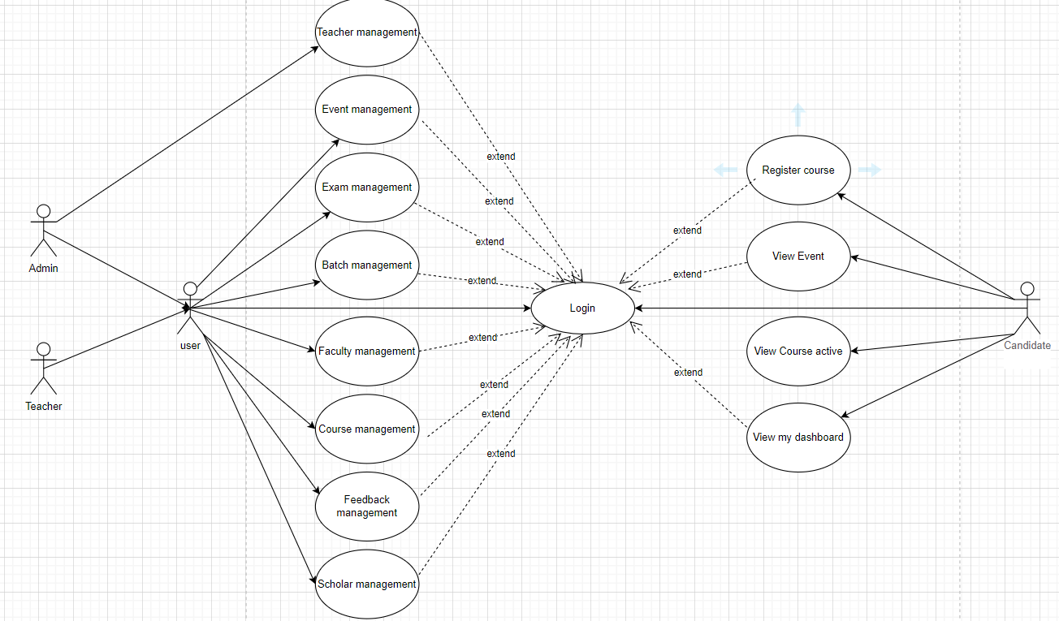

**Hình 1 : General use-case diagram**

**4. Specification of Use-case diagram details**

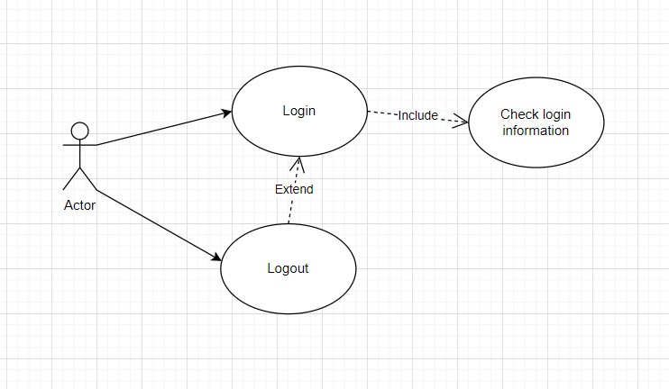

**Hình 2 : Login Diagram**

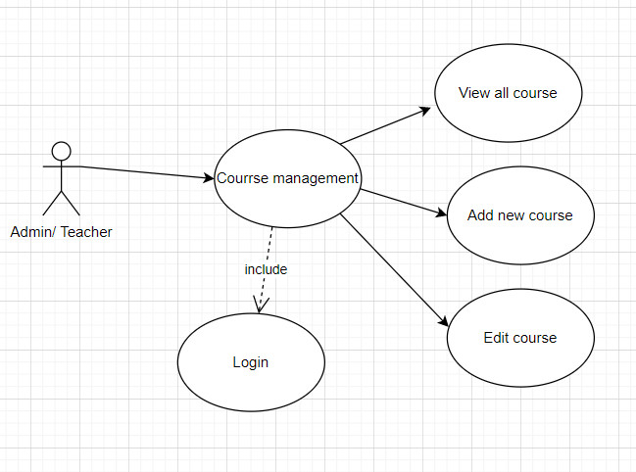

**Hình 3 : Course Management**

**CHAPTER IV: DESIGN AND READ THE DATABASE**

1. **Indentify Database Table**
   1. 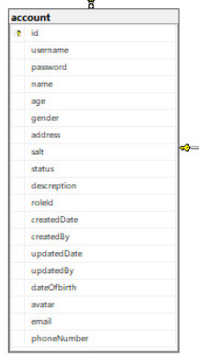Table “account”
   2. 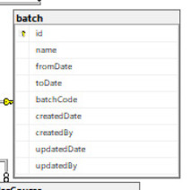Tabel “bath”
   3. 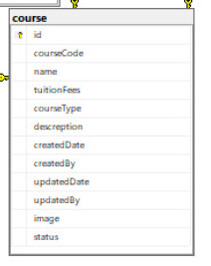Table “course”
   4. 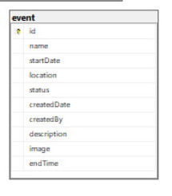Table “event”

* 1. Table “exam”

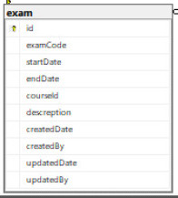

* 1. 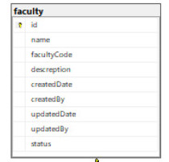Table “faculty”
  2. 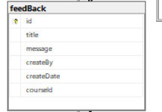Table “feedBack”
  3. 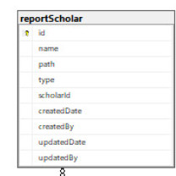Table “reportScholar”
  4. 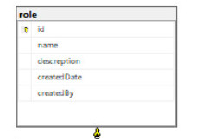Table “role”
  5. 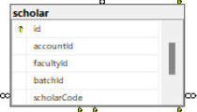Table “scholar”
  6. 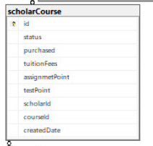Table “scholarCourse”
  7. 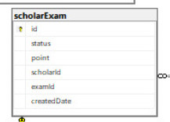Table “scholarExam”

1. 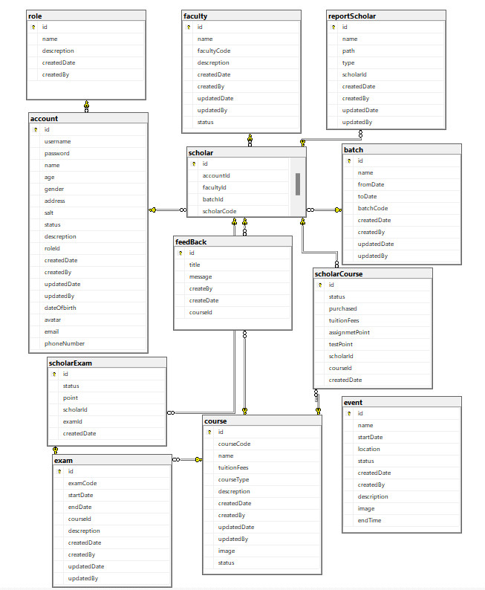**Entity Relationship Diagram**

**CHAPTER V: INTERFACE DESIGN AND READING**

1. 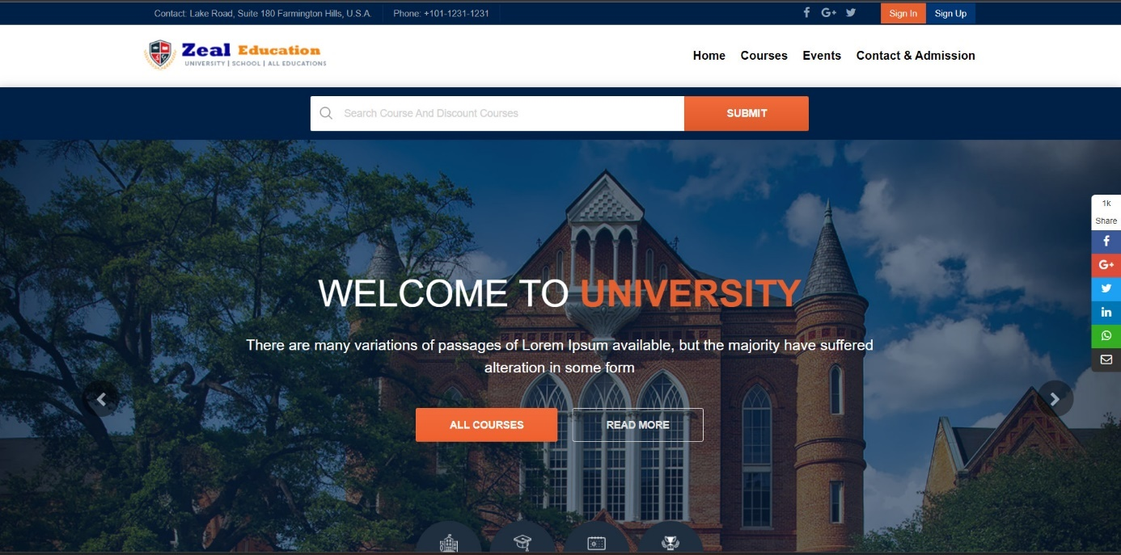**Home page**

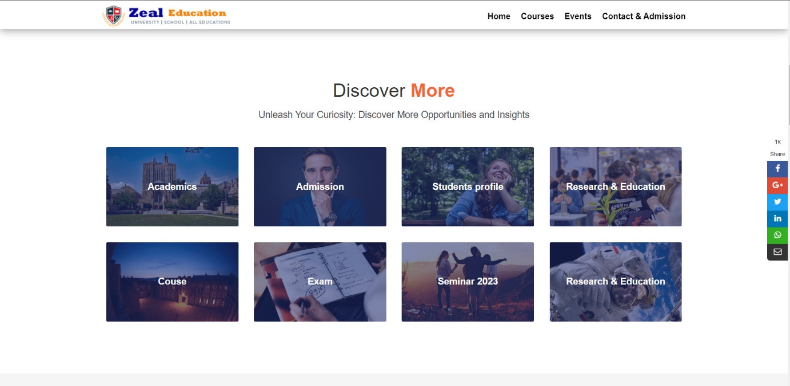

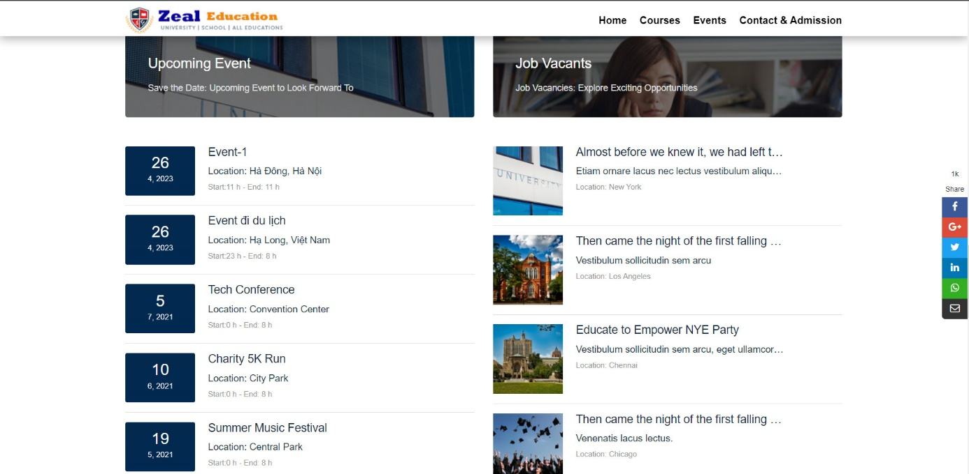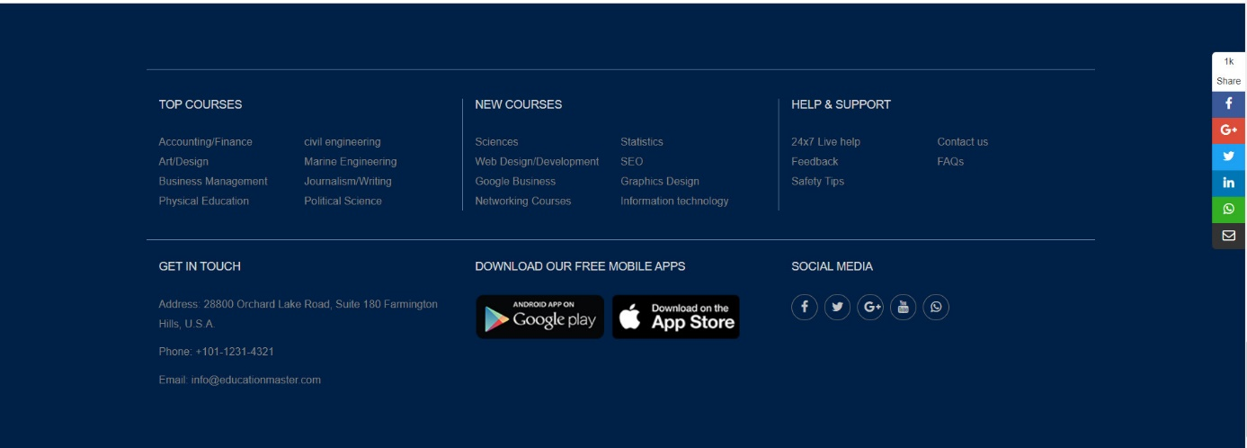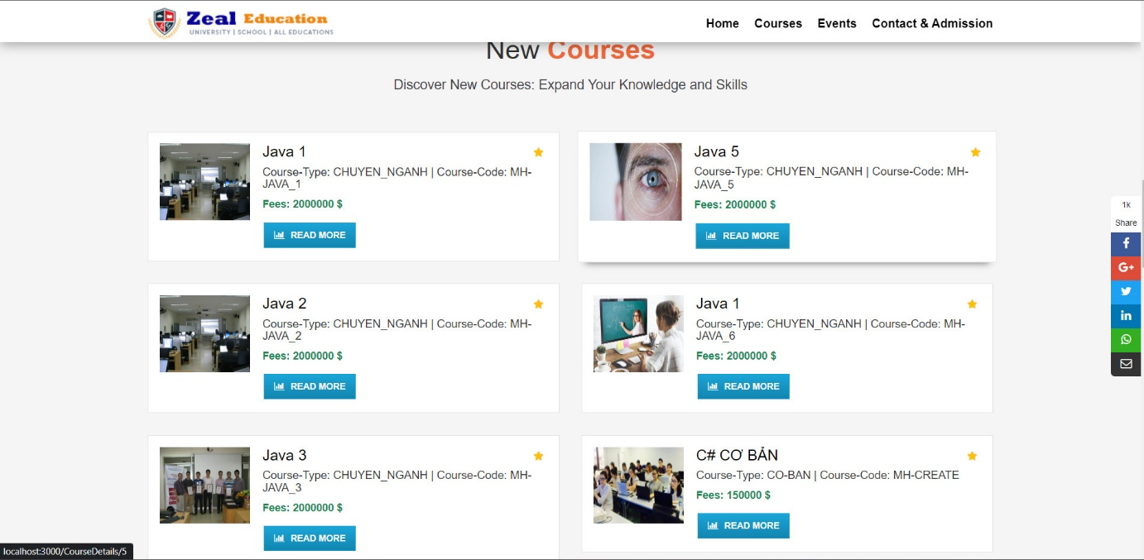

1. 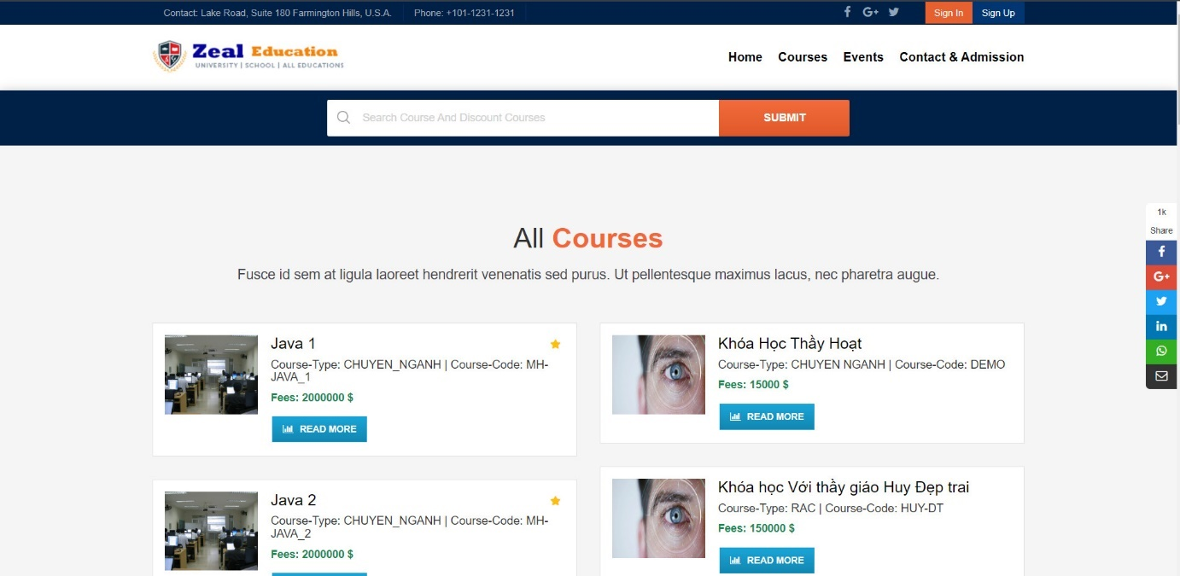**C****ourse page interface**
2. **Course detail page interface**

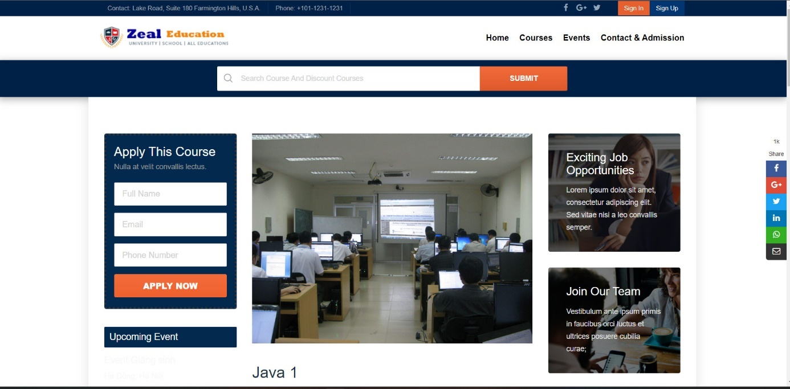

1. 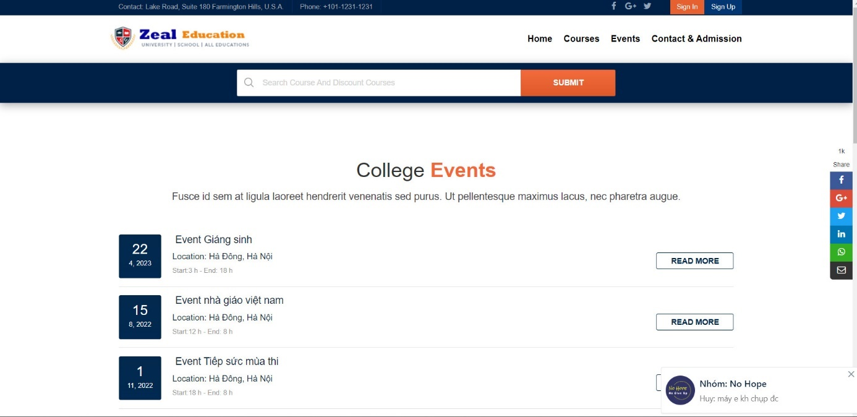**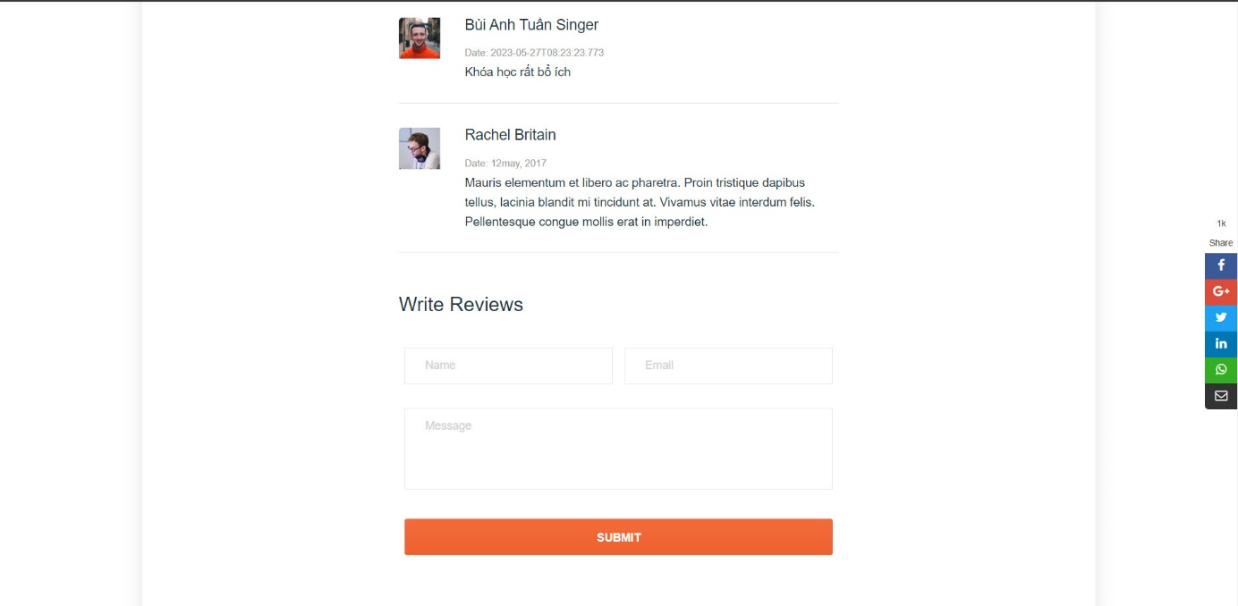E****vent** **Page** **Interface**
2. 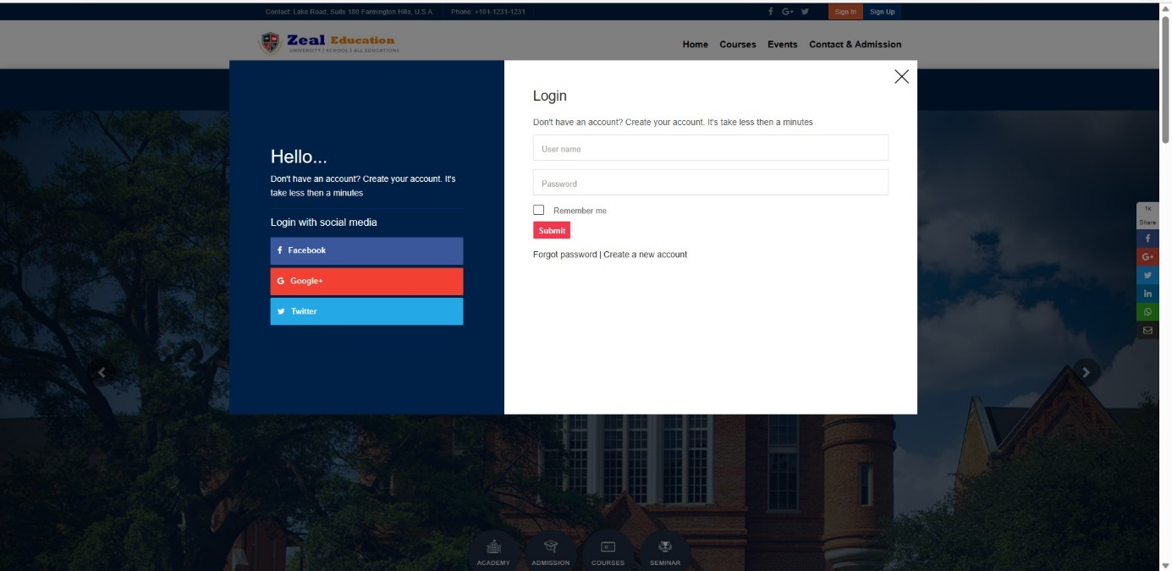**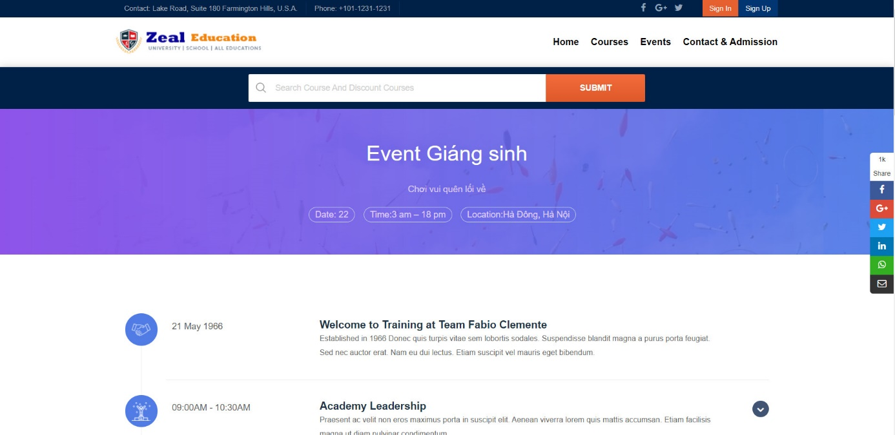Login** **Page** **Interface**

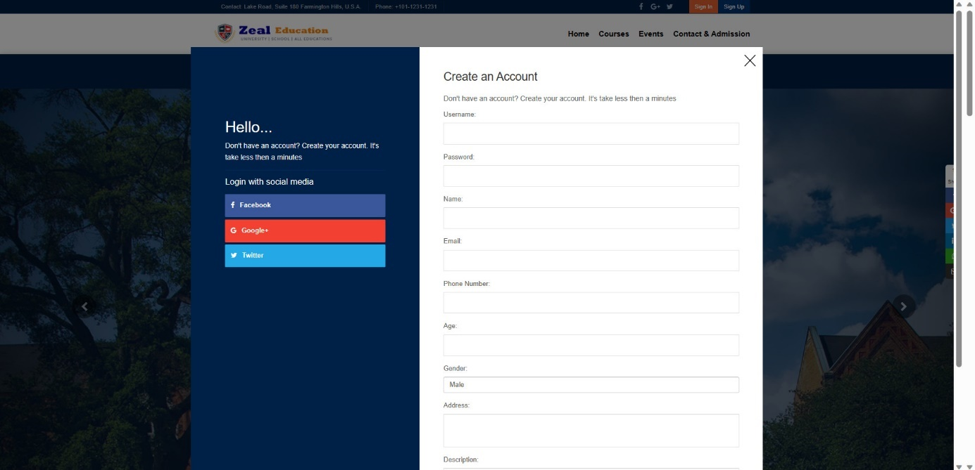

1. 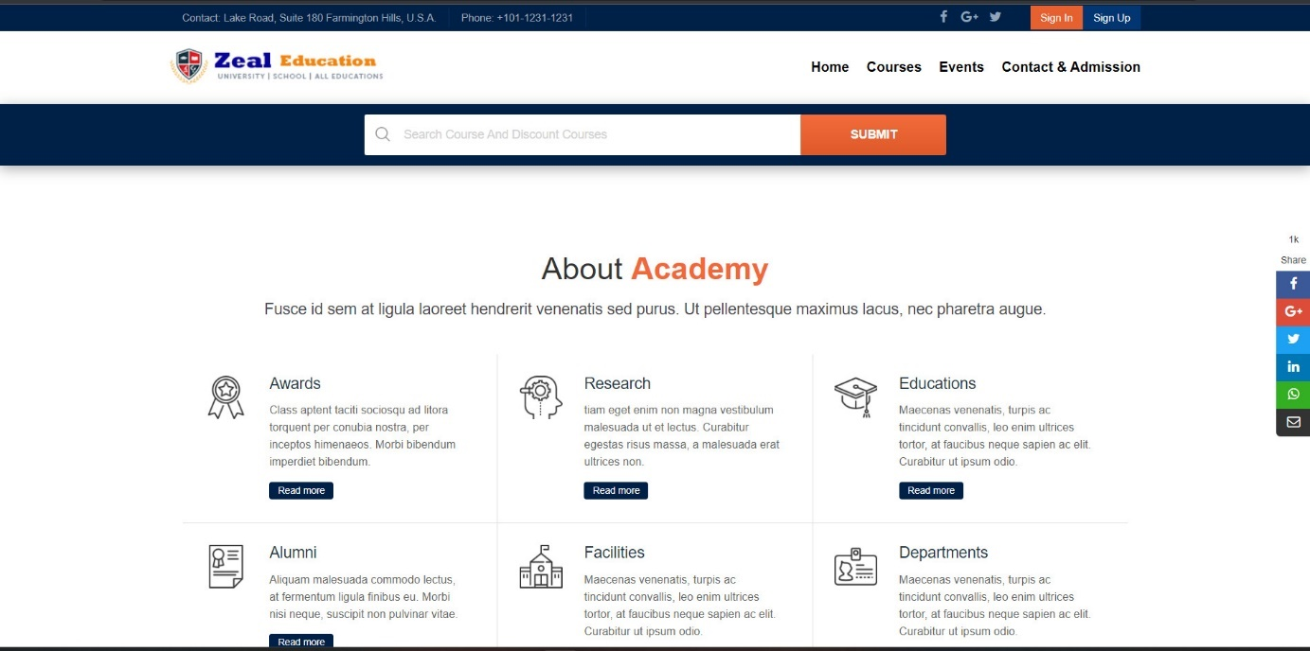**About** **us** **page** **interface**
2. 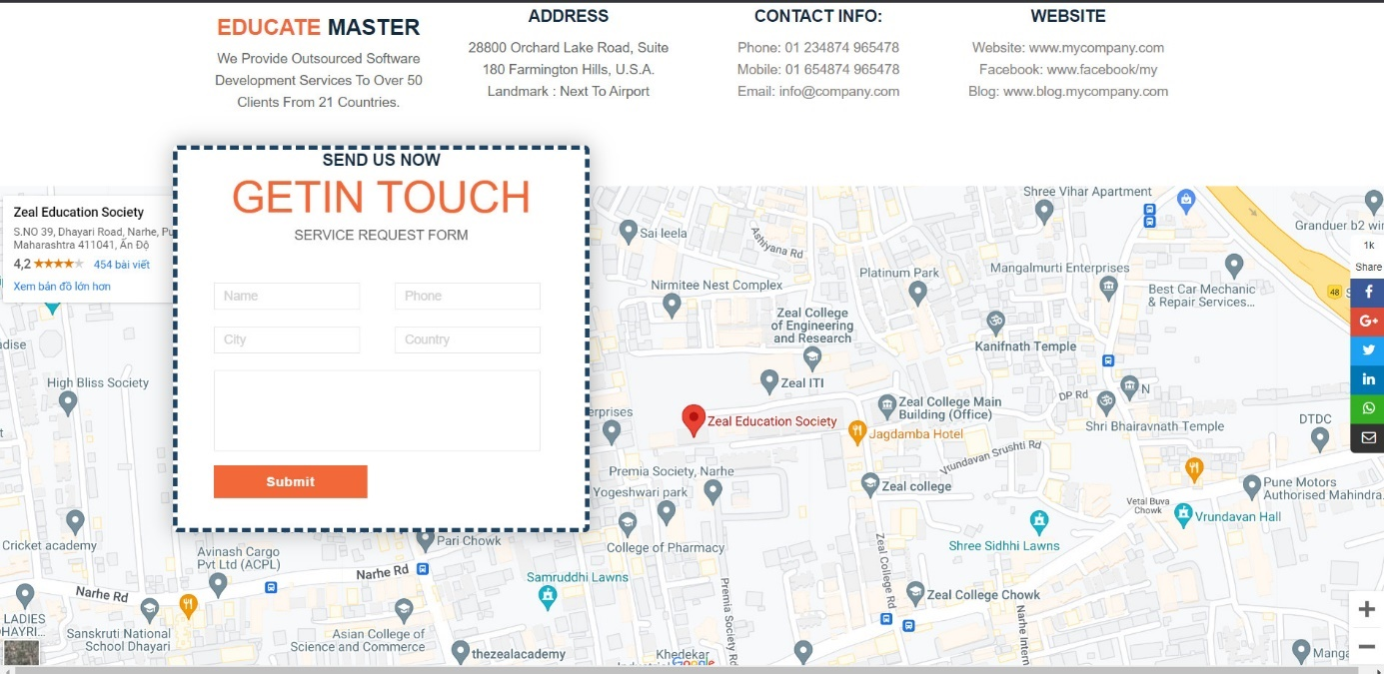**Contact** **us** **page** **interface**
3. **Scholar** **Page** **Interface**

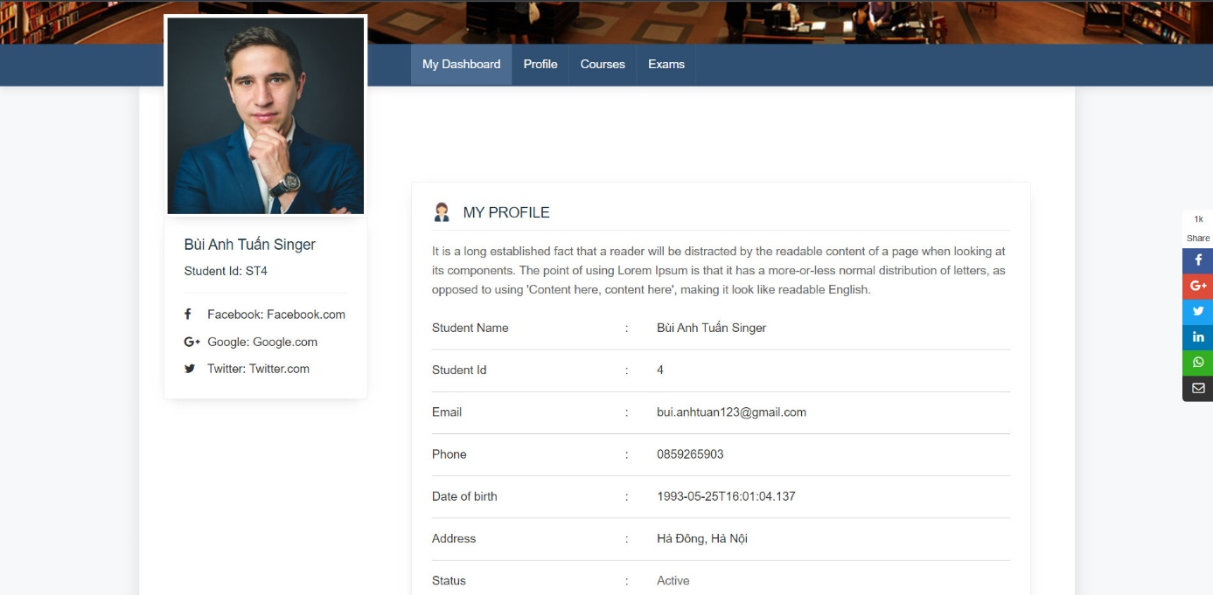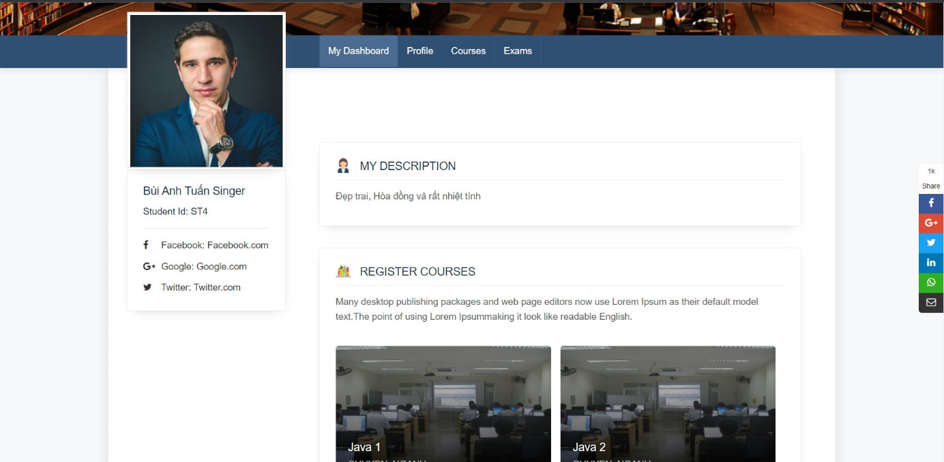

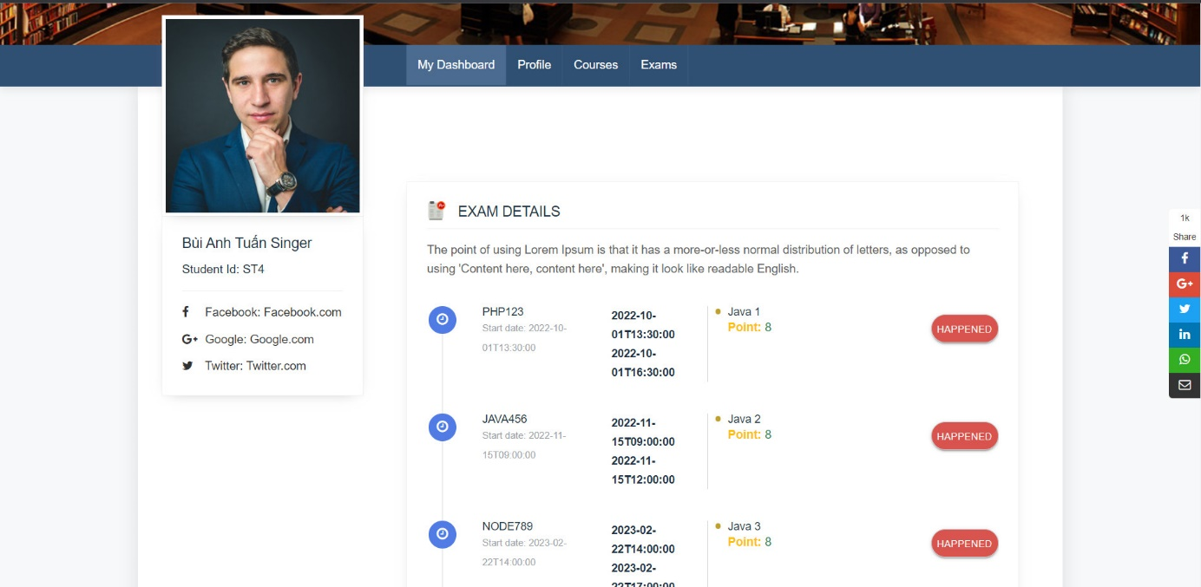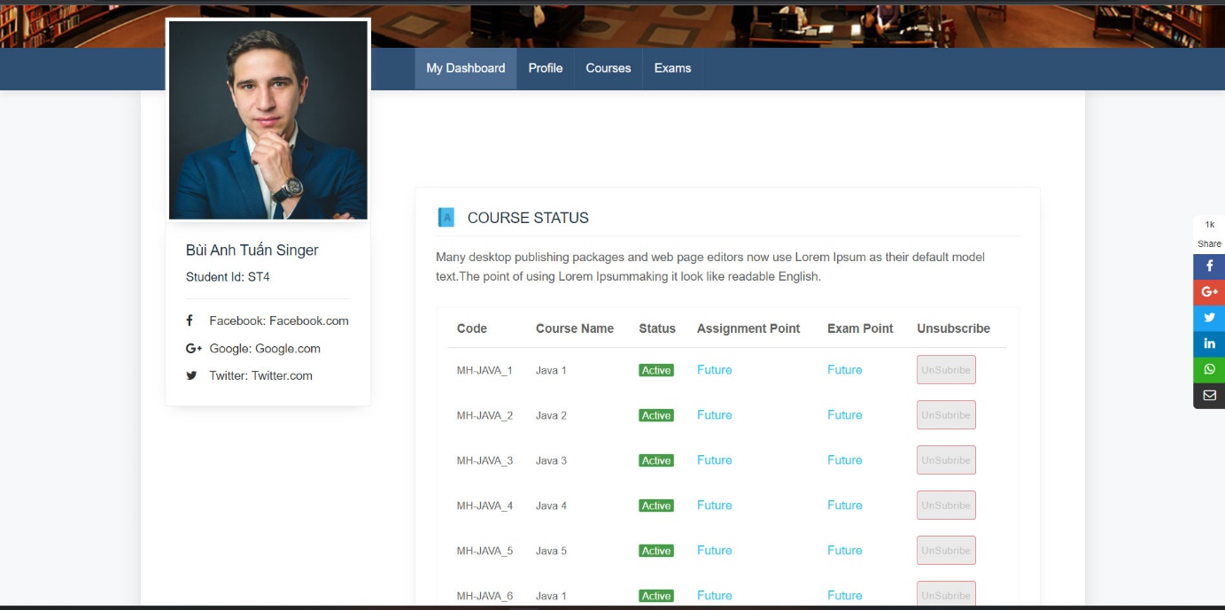

1. 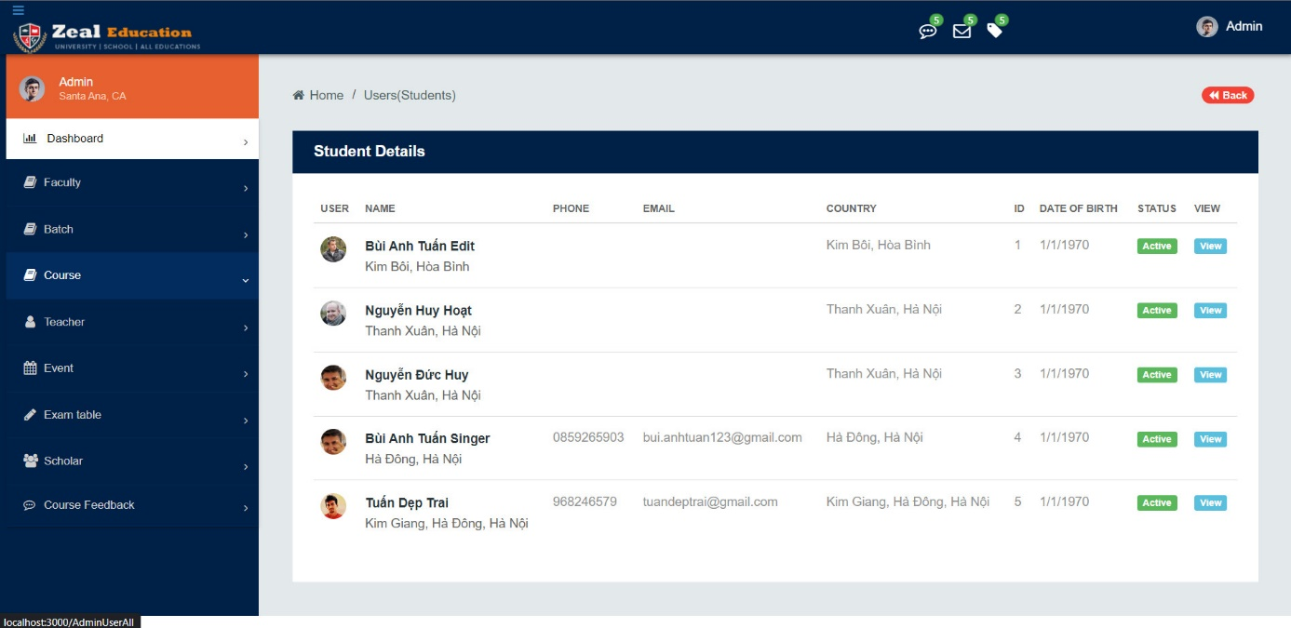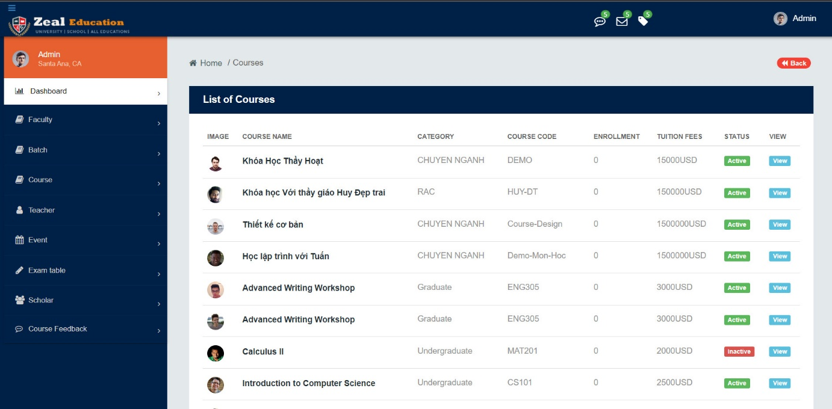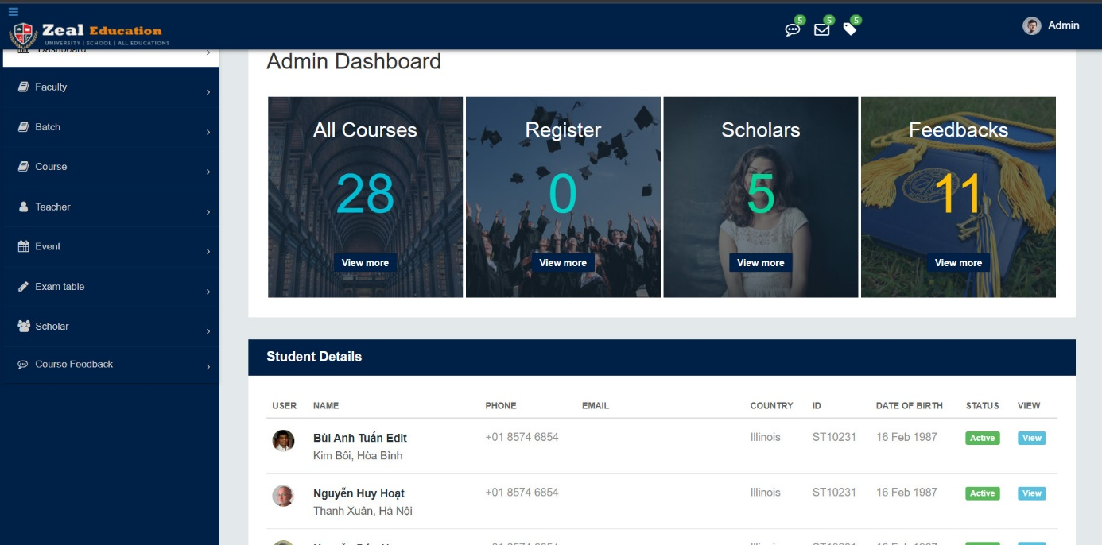**Admin** **page** **interface**

**CHAPTER** **VI:** **SUMMARY**

Result:

+ The website has all the basic functions of a job search website + Good security for those who have the right to use it.

+ Accurate fast processing speed.

Limitations: The software development process has encountered many difficulties such as building according to the model, processing time, etc. The website is still in the process of completion, so it is inevitable that there will

be shortcomings. Contributions from teachers will be very valuable to us in software development

Future development direction:

+ The educational management website will continue to improve and develop features as well as establish new forms to build a good, complete and strong system to serve the needs of people's interests. , bringing diversity to human life.

+ Meet the real-time running (realtime).

# REFERENCE DOCUMENTS

[1]. Web Programming Course, .Net MVC, API

[2]. Documents Reactjs

[3]. [HTML Tutorial (w3schools.com)](https://www.w3schools.com/html/default.asp).

[4]. [CSS Tutorial (w3schools.com)](https://www.w3schools.com/css/default.asp).

[5]. [JavaScript Tutorial (w3schools.com)](https://www.w3schools.com/js/default.asp).

Use IDE:

+ SQL Server management

+ Visual Studio 2022

+ Visual Studio Code

+ Azure

+ Github

**Evaluate individual work of team members:**

1. Bùi Anh Tuấn (leader)
   1. Design Database
   2. Code backend (backend management)
2. Mai Huy Hoạt
   1. Code Frontend (frontend management)
3. Ngô Lê Minh Tùng
   1. Code backend
   2. Code frontend
4. Nguyễn Đức huy
   1. Code backend
5. Đinh Văn Linh
   1. Code frontend

**THANK YOU**

In fact, there is no success that is not tied to the support and help, whether it is direct or indirect, of others. During the time since we started studying at FPT APTECH University until now, we have received a lot of attention and help from teachers, family and friends.

With our deepest gratitude, we would like to send to the teachers at the Faculty of Information Technology - FPT APTECH University with their knowledge and enthusiasm to impart valuable knowledge to us throughout the year. study time at school. And especially, in this term, we have access to a subject that is very useful for students of Information Technology. That is the subject: "Advanced Web Programming Project".

We would like to sincerely thank Mr. Man Ngoc Lam for his dedicated guidance during the past time of studying and practicing.

Although I have tried very hard to complete the report with all my efforts, however, due to the initial step of putting it into practice, learning and building the report in a limited time, and limited knowledge, many problems. thought, so the report "Building an education management website Zeal Education" will certainly inevitably have shortcomings. We look forward to receiving the attention, understanding and valuable contributions of teachers and friends to make this report more complete.

Once again, we sincerely thank you and look forward to receiving your contributions. Best regards.